Finding Data Trends With Visualizations
Mr. Harrington_Model
- What topic did you enter? Did you add any Filters that would have affected the search?
I entered National Rifle Association (NRA) over the last 5 year period.
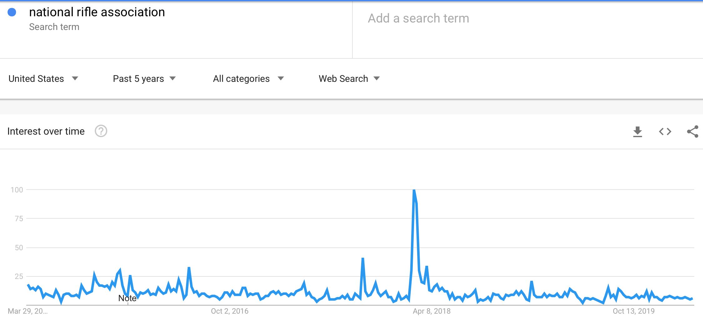

I then entered NRA & Compared it to “Gun Control” over the last 5 year period.
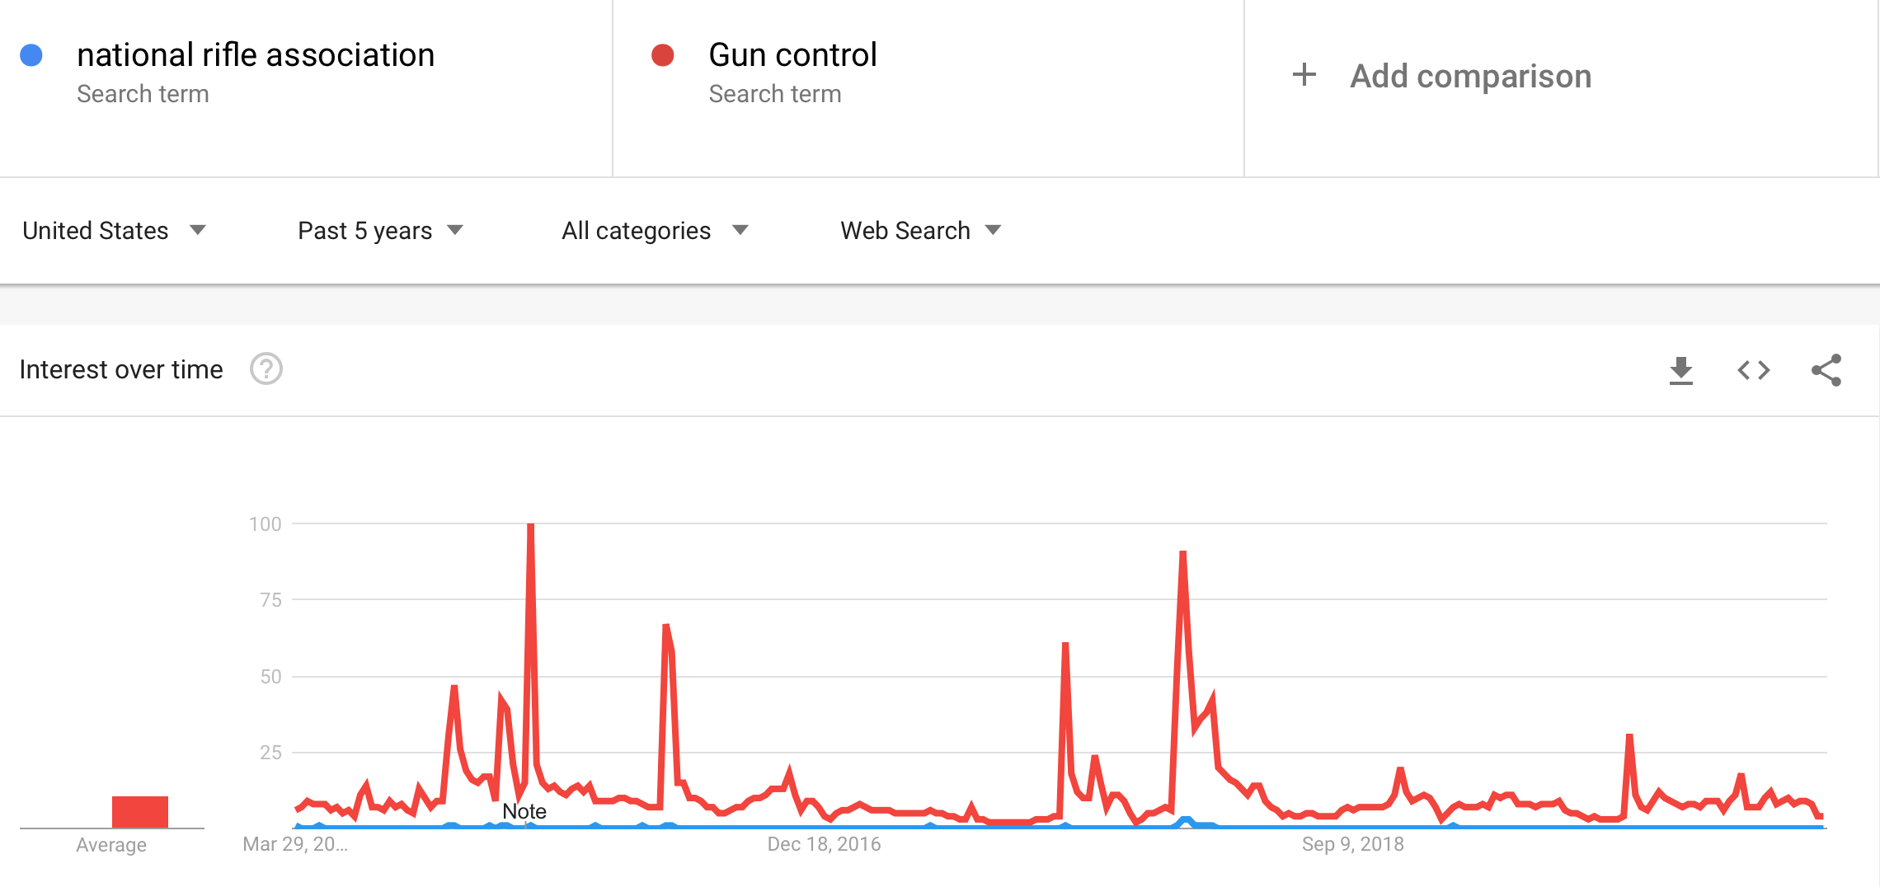
- Accurately ​ ​describe what the charts or other visualizations are showing.​
You can notice that the spikes are somewhat in sync between these two charts. I researched the dates on the charts. Each one matched a mass shooting in America (eg. Virginia Beach, Bakersfield, El Paso Texas, Thousand Oaks, CA, etc.).

- Come up with a ​possible story or explanation of why the trend you described might have happened.
Remember, these spikes are not actual gun sales or gun control laws being passed. It is a fact that gun sales always spike following a mass shooting. People fear that they had better buy a gun now, just in case gun control laws are passed. Most likely, these search spikes are being made by individuals who want to find out if any gun regulations are being written.

